1. 
2. This repo contains different projects which we will **containerize** in this course.
3. 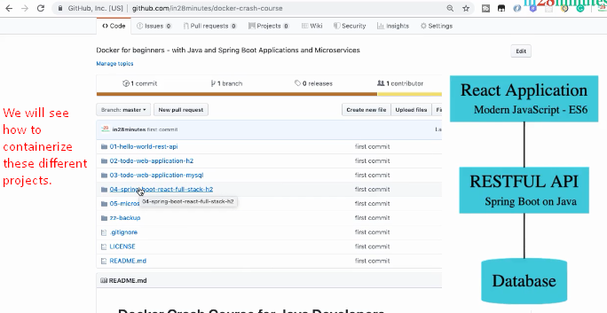
4. We assume that you have some knowledge about the followings.
   1. Spring, Spring Boot, JPA, Hibernate, React
5. 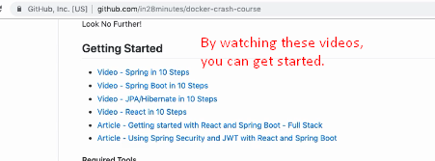
6. **Installation Guidelines**: Let’s move to installation Guideline sections which contain installation instructions for different tools that we would be using during this course.
7. 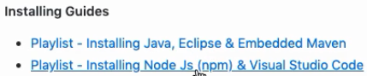
   1. For the first section of the course, we will be using Java (Greater than 8), Eclipse (Latest Version) and embedded maven.
   2. When we get to the Full-Stack app, we can install node.js and visual studio code.
8. **Troubleshooting installation**. If in case you have any issues while installation. 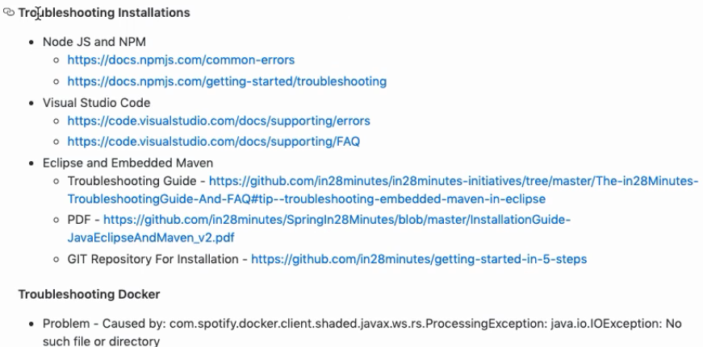  
   Each of these project contains README file with more details about the project.